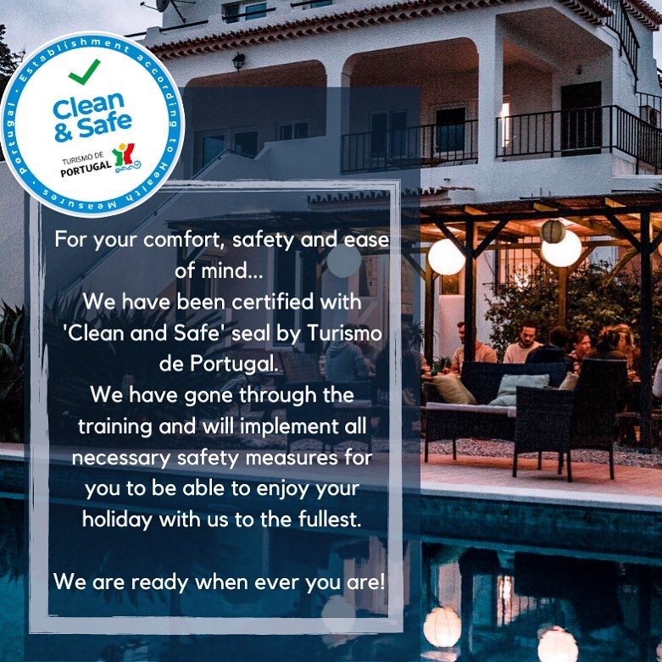

AltaVista
Special measures — COVID-19

What is COVID-19
Coronavirus disease 2019 (COVID-19)is defined as illness caused by a novel coronavirus now called severe acute respiratory syndrome coronavirus 2(SARS - CoV-2; formerly called 2019 n CoV), which was first identified amid an outbreak of respiratory illness cases in Wuhan City, Hubei Province, China.

At our Lodge
- AltaVista Lodge has attended the Turismo de Portugal "Clean and Safe" training and we will implement all the necessary measure for our guests to make them feel safe and at ease.

- The capacity of the place is reduced by 50%. Maximum we can accommodate is 20 people this season, so that the distance between beds is sufficient.

- This season we will not be able to provide maid service during your stay. The rooms will be cleaned and disinfected on change over days. Clean sheets and towels will be left outside the rooms for stays over 7 nights.

- There will be disinfecting sprays located all through the Lodge.

- Kitchen will be closed for guests. Only staff members are allowed to cook. We provide complimentary daily breakfast buffet. We offer snacks and drinks at our Buddha Bar. Dinner can be booked with us. Many restaurants and cafes are a short walking distance (10mins) in Luz.

- Breakfast will be served in a safe manner. Explained to the guests on arrival.

- Guests will be advised to wear a face mask inside the Lodge common areas. Not outside. You can purchase a medical mask at our reception and bar.

- Sunbathing by the pool is possible while taking in consideration 1.5m distance. We have a extensive sub-tropical gardens and surroundings so there is plenty of space to sunbathe and relax in safe manner.

- Surf school and activity providers will provide their own safety measures for guests have to comply with.

- Let's all work together so that we can enjoy summer to the fullest and have a great time filled with adventure, relaxation and new friends.
————————————————————————————————————————————————————
- AltaVista Lodge has attended the Turismo de Portugal "Clean and Safe" training and we will implement all the necessary measure for our guests to make them feel safe and at ease.

- The capacity of the place is reduced by 50%. Maximum we can accommodate is 20 people this season, so that the distance between beds is sufficient.

- This season we will not be able to provide maid service during your stay. The rooms will be cleaned and disinfected on change over days. Clean sheets and towels will be left outside the rooms for stays over 7 nights.

- There will be disinfecting sprays located all through the Lodge.
- Kitchen will be closed for guests. Only staff members are allowed to cook. We provide complimentary daily breakfast buffet. We offer snacks and drinks at our Buddha Bar. Dinner can be booked with us. Many restaurants and cafes are a short walking distance (10mins) in Luz.

- Breakfast will be served in a safe manner. Explained to the guests on arrival.

- Guests will be advised to wear a face mask inside the Lodge common areas. Not outside. You can purchase a medical mask at our reception and bar.

- Sunbathing by the pool is possible while taking in consideration 1.5m distance. We have a extensive sub-tropical gardens and surroundings so there is plenty of space to sunbathe and relax in safe manner.

- Surf school and activity providers will provide their own safety measures for guests have to comply with.

- Let's all work together so that we can enjoy summer to the fullest and have a great time filled with adventure, relaxation and new friends.
————————————————————————————————————————————————————
Please take the common health & safety recommendations seriously
- Maintain the recommended safety distance of 2m from other people
- Wash your hands regularly with soap or alcohol-based hand rub
- Disinfect surfaces. Increase ventilation by opening windows or adjusting air conditioning
- Check yourself forCOVID-19 symptoms on a daily basis, measure your temperature
- Don’t touch your eyes, nose and mouth. Cover your nose and mouth with your elbow bent or a tissue

Common Symptoms
Fever - Dry Cough - Fatigue - Breathing Difficulties - Aches / Pains - Diarrhoea - Loss of taste or smell

What is Clean & Safe?
‘Clean and Safe’ is a certification that was released by the Portuguese Tourism Board. We are following ‘Clean and Safe’ Protocol to make your holiday with us both enjoyable and safe

Please take the common health & safety recommendations seriously
If anybody feels symptoms of Covid 19 contact SNS24 Line (808 24 24 24) or Family Health Unit Line or Personalised Health Care Unit

